PROJECT REPORT

1 INTRODUCTION

* 1. IDEATION & BRAINSTORMING

Ideation is commonly more thought of as being an individual pursuit, while brainstorming is almost always a group activity

* 1. Empathy

An empathy map is a tool used in design thinking to build an emotional representation of a user or the customer.

2 PROBLEM DEFINITION & DESIGN THINKING

2.1 EMPATHY MAP

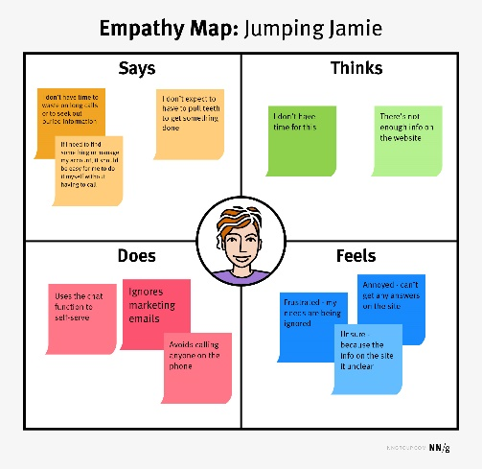

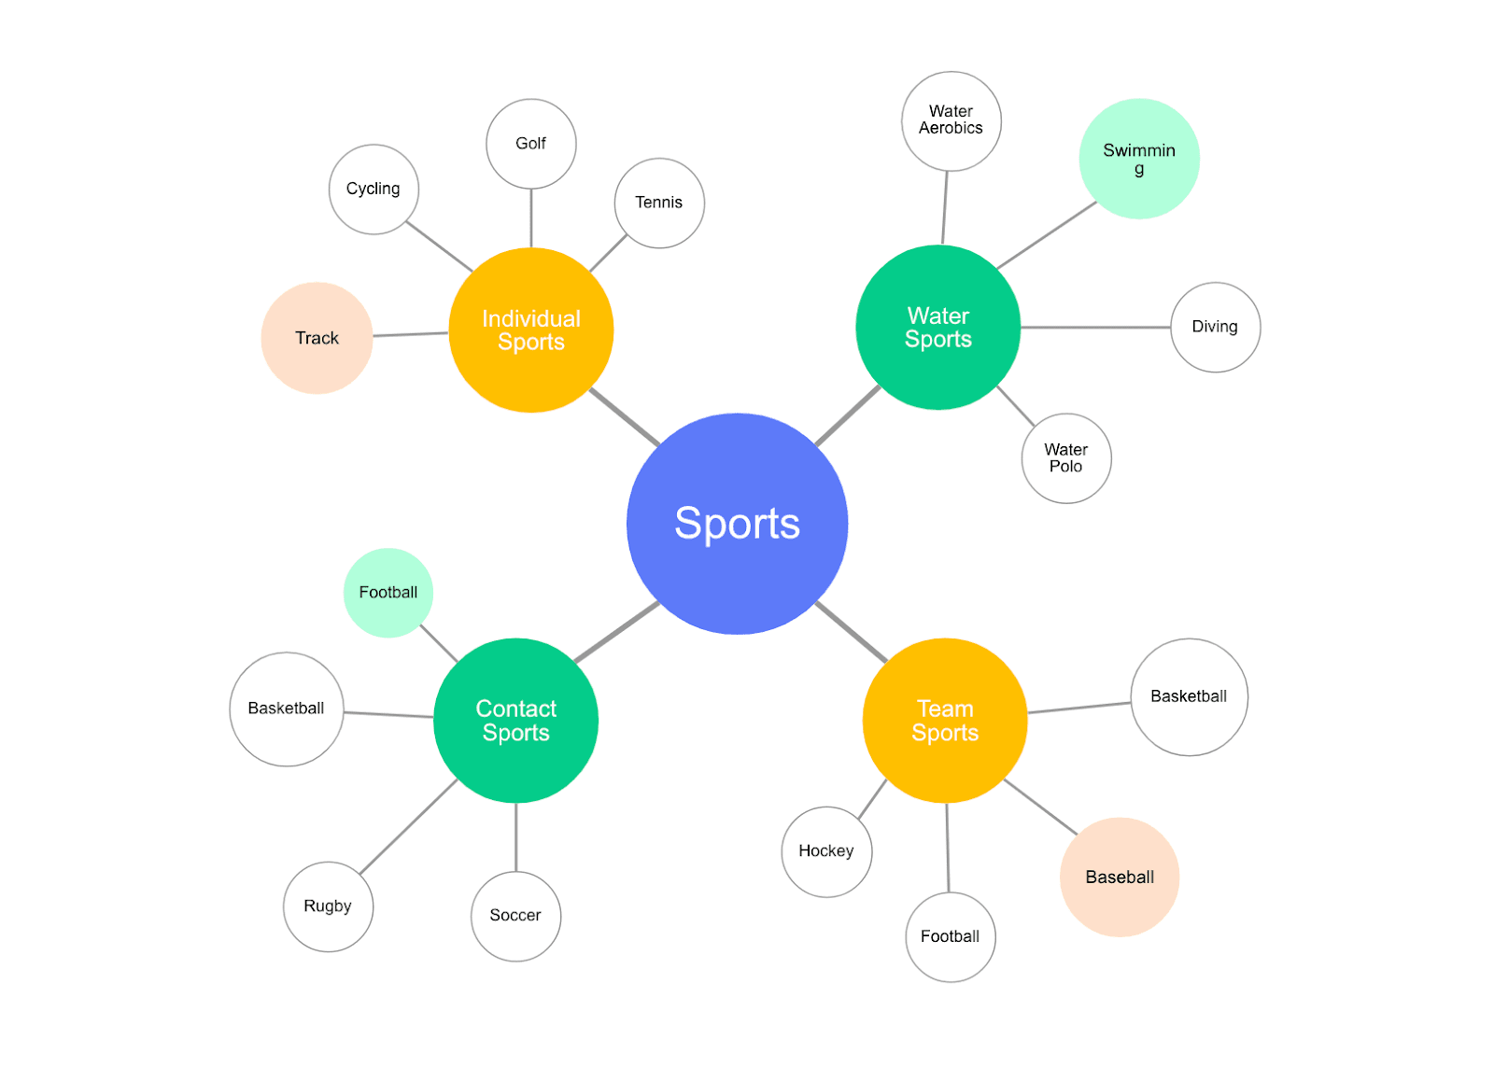2.2 IDEATION & BRAINSTORMING

3 RESULT

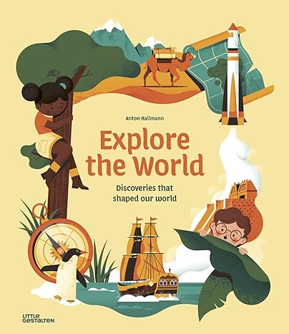

4 ADVANTAGES & DISADVANTAGES

* + Helps to map what a design team knows about the potential audience
  + May not capture the needs and perspectives of other stake holders.
  + It can helps you find creative solutions , poster collaboration , and stimulate innovation.

5 APPLICATION

One of the most significant benefits of canva is the unlimited access to premium templates and assets. In that we took travel templates. Travel to make memories all around the world.

6 CONCLUSION

Life is about the adventures you take and the memories you make. Sometimes in life no matter how fast you are moving, you need to slow down and pay attention to travel.